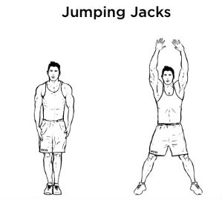
Jumping Jacks

Works coordination & cardiorespiratory endurance
Muscles: Calf Muscles, Deltoids, Gluteus
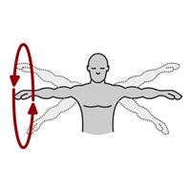
Arm Circles
Works muscular endurance
Muscles: Deltoids

1 Leg in Air Balance
Works Balance
Muscles: Hamstrings

Knee Push-Ups
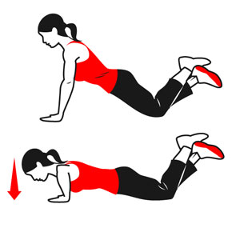
Works Muscular Strength & Muscular Endurance
Muscles: Pectorals, Deltoids, Triceps
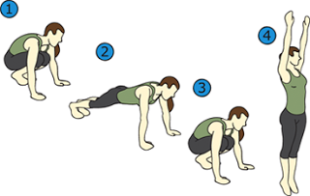
Burpees

Works Muscular Strength & Muscular Endurance
Muscles: Quadriceps, Pectorals, Deltoids, Gluteus
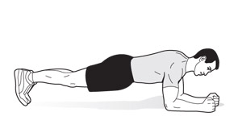
Plank

Works Muscular Strength & Muscular Endurance
Muscles: Abdominals
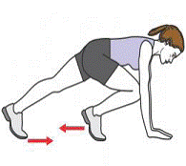
Mountain Climbers

Works Muscular Strength, Muscular Endurance & Cardiorespiratory Endurance
Muscles: Quadriceps, Calf Muscles, Pectorals, Gluteus, Deltoids, Abdominals, Hamstrings, Triceps
Jump Rope
Works Cardiorespiratory Endurance
Muscles-Calf Muscles, Quadriceps, Hamstrings, Biceps, Triceps, Deltoids
Lunges
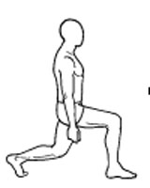
Works Muscular Strength & Muscular Endurance
Muscles-Quadriceps, Hamstrings, Gluteus,

Stretches (Figure 4, Butterfly, Legs Straight, V-Stretch)
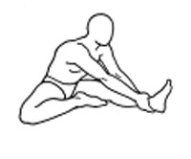
Works Flexibility
Muscles: Hamstrings

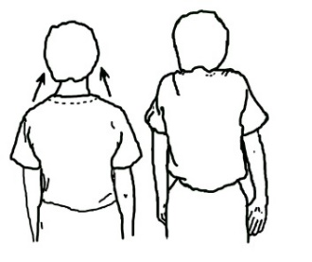
Shoulder Shrugs
Works Muscular Endurance
Muscles: Trapezius

Sit-Ups
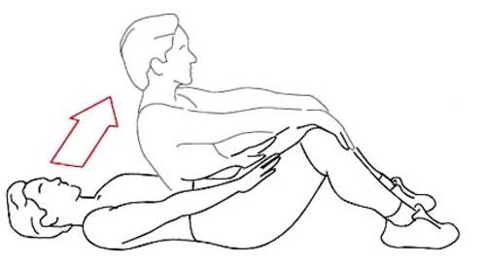
Works Muscular Strength & Muscular Endurance
Muscles: Abdominals
Sprints
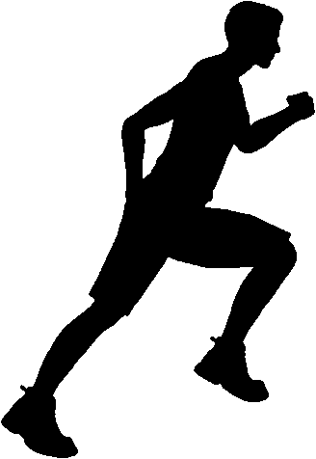
Works Cardiorespiratory Endurance
Muscles: Quadriceps, Hamstrings, Calf Muscles, Gluteus, Abdominals

Line Jumps
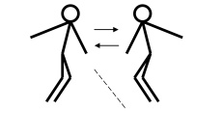
Works Muscular Endurance & Cardiorespiratory Endurance
Muscles: Calf Muscles

